TASK 1:

#include<iostream>

#include<fstream> output

using namespace std;

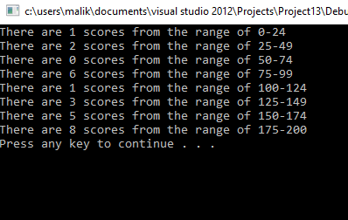int main()

{

ifstream infile;

infile.open("marks.txt");

int n,count[7];

for(int i=0;i<=7;i++)

{

count[i]=0;

}

while(infile>>n)

{

if(n>=0 && n<=24)

{

count[0]=count[0]+1;

}

if(n>=25 && n<=49)

{

count[1]=count[1]+1;

}

if(n>=50 && n<=74)

{

count[2]=count[2]+1;

}

if(n>=75 && n<=99)

{

count[3]=count[3]+1;

}

if(n>=100 && n<=124)

{

count[4]=count[4]+1;

}

if(n>=125 && n<=149)

{

count[5]=count[5]+1;

}

if(n>=150 && n<=174)

{

count[6]=count[6]+1;

}

if(n>=175 && n<=200)

{

count[7]=count[7]+1;

}

}

cout<<"There are "<<count[0]<<" scores from the range of 0-24 "<<endl;

cout<<"There are "<<count[1]<<" scores from the range of 25-49 "<<endl;

cout<<"There are "<<count[2]<<" scores from the range of 50-74 "<<endl;

cout<<"There are "<<count[3]<<" scores from the range of 75-99 "<<endl;

cout<<"There are "<<count[4]<<" scores from the range of 100-124 "<<endl;

cout<<"There are "<<count[5]<<" scores from the range of 125-149 "<<endl;

cout<<"There are "<<count[6]<<" scores from the range of 150-174 "<<endl;

cout<<"There are "<<count[7]<<" scores from the range of 175-200 "<<endl;

system ("pause");

return 0;

}

TASK 2:

#include<iostream>

#include<string>

#include<fstream> OUTPUT:

using namespace std;

int main ()

{

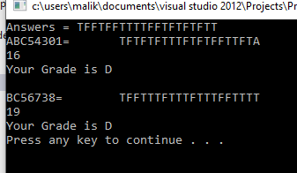 string id;

char a[20],Rightans[20];

int i,j;

float counter=0,per;

ifstream file;

file.open("file.txt");

ifstream infile;

infile.open("record.txt");

cout<<"Answers = ";

for(j=0;j<=19;j++)

{

file>>Rightans[j];

cout<<Rightans[j];

}

while(infile>>id)

{

cout<<endl<<id<<"=\t";

j=0;

counter=0;

for(i=0;i<=19;i++)

{

infile>>a[i];

cout<<a[i];

if(Rightans[j]==a[i])

{

counter=counter+2;

}

else if(Rightans[j]!=a[i])

{

counter=counter-1;

}

else

{

counter=counter+0;

}

j++;

}

cout<<endl<<counter<<endl;

per=(counter/40)*100;

if(per<=100 && per>=90)

{

cout<<"Your Grade is A"<<endl;

}

else if(per<=89.99 && per>=80)

{

cout<<"Your Grade is B"<<endl;

}

else if(per<=79.99 && per>=60)

{

cout<<"Your Grade is C"<<endl;

}

else if(per<=59.99 && per>=40)

{

cout<<"Your Grade is D"<<endl;

}

else

{

cout<<"Your Grade is F"<<endl;

}

}

system ("pause");

return 0;

}

TASK 3:

#include<iostream>

#include<string>

#include<fstream>

using namespace std;

int main ()

{

ofstream infile;

infile.open("votes.txt");

string name[5];

float votes[5],Tv=0,per[5],large=0;

infile<<"Candidate\tVotes Receive\tPercentage of total votes\n";

for(int i=0;i<=4;i++)

{

cout<<"Enter the name = ";

cin>>name[i];

infile<<name[i]<<"\t\t\t";

cout<<"Enter votes = ";

cin>>votes[i];

infile<<votes[i]<<"\n";

}

for(int j=0;j<=4;j++)

{

Tv=Tv+votes[j];

}

infile<<"Total votes\t\t"<<Tv;

infile<<"\nCandidate\tVotes Receive\tPercentage of total votes\n";

cout<<"Candidate\tVotes Receive\tPercentage of total votes\n";

for(int k=0;k<=4;k++)

{

infile<<name[k]<<"\t\t\t";

cout<<name[k]<<"\t\t\t";

infile<<votes[k]<<"\t\t";

cout<<votes[k]<<"\t\t";

per[k]=(votes[k]/Tv)*100;

infile<<per[k]<<endl;

cout<<"%"<<per[k]<<endl;

}

infile<<"Total votes\t\t"<<Tv;

cout<<"Total votes\t\t"<<Tv;

for(int l=0;l<=4;l++)

{

if(large<votes[l])

{

large=votes[l];

}

}

for(int m=0;m<=4;m++)

{

if(votes[m]==large)

{

cout<<" The winner of this Election is: "<<name[m];

infile<<" The winner of this Election is: "<<name[m];

}

}

system("pause");

return 0;

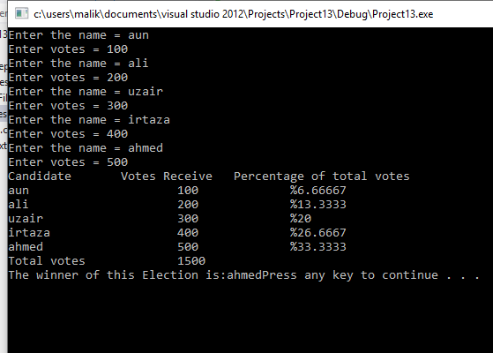}

OUTPUT:

TASK 4:

#include<iostream>

using namespace std;

int Zeroarry[1],inStock[10][4],alpha[20],beta[20],gamma[4] = {11, 13, 15, 17},delta[10] = {3, 5, 2, 6, 10, 9, 7, 11, 1, 8};

void setzero()

{

int n;

cout<<"Enter the range of arry you want to set zero=";

cin>>n;

for(int i=0;i<n;i++)

{

Zeroarry[i]=0;

cout<<Zeroarry[i]<<endl;

}

}

void alpha_beta()

{

cout<<"Enter 20 numbers=";

for(int i=0;i<=19;i++)

{

cin>>alpha[i];

beta[i]=2*alpha[i];

cout<<"Beta="<<beta[i]<<endl;

}

}

void printarry()

{

int num;

cout<<"Enter the range of an array = ";

cin>>num;

for(int i=0;i<num;i++)

{

if(i%15==0)

{

cout<<endl;

}

cout<<Zeroarry[i]<<" ";

}

}

int main()

{

setzero();

alpha_beta();

printarry();

return 0;

}